horizontal line

**Takouba**

Veterans Affairs

Participatory System Dynamics Platform   
(to Increase Timely Access to VHA Evidence-based Outpatient Mental Health Care)

**Design Document -- Iteration C**

Tue 26-Dec 2017  
Version 5

horizontal line

# Document History & Status

|  |  |  |
| --- | --- | --- |
| Version | Date | Description/ Status |
| v 1 | 17-Nov 2017 | Start of Document / Development. |
| v 2 | 19-Dec 2017 | External G-SS for variables info (for Agg model). |
| v 3 | 21-Dec 2017 | Removed variable table, added some graphics, notes for review. |
| v 4 | 26-Dec 2017 | Takouba review. |
| v 5 | 26-Dec 2017 | Release version for development. |



**Table of Contents (Quick Link)**

Document History & Status

Objective of This Document

Basics

Iteration Objectives

Key Dates

Graphic Standards and 508 Accessibility Standards

Vensim Model(s)

Roles

Page Flows, Wireframes, and Graphics

Graphics

Wireframes

SOW Requirements

2.02 Admin’s Dashboard / Administration Features / 5.2.1. Basic Administrative Functionality for administration from the National Center for PTSD

2.02 Admin’s Dashboard / Administration Features / 5.6.2. Overview page with list of users and their current progress

2.03 Player’s Dashboard / 5.9.10 Decisions Page (for Agg)

2.03 Player’s Dashboard / 5.9.6 Dashboard with access to key metrics (Agg)

2.03 Player’s Dashboard / 5.9.12 Ability to export data as a Comma Separated Values (CSV) File

2.03 Player’s Dashboard / 5.10.01 Introduction & Help: Text-based 'prepare' section

[(Help Page Content) 2.03 Player’s Dashboard / 5.10.02 Introduction & Help: Text-based 'help' section AND   
2.03 Player’s Dashboard / 5.10.03 Integrate tutorial videos AND   
2.03 Player’s Dashboard / 5.10.04 Interactive tutorial walking through the user interface](#_hk7zanbp4md5)

[2.04 Retune the Model for Different Locations / 5.3.1 Framework for Multiple Cities, States, other Locations AND   
5.3.2 Ability to Upload Datasets by Location](#_oltztmguosr)

2.05 User Management / 5.4.2 Upload List of Users from a Comma Separated Values (CSV) file

2.05 User Management / 5.9.3 Set team name

2.06 Game Assignment / 5.4.3 Assign Users to Roles (Role Player, Simulation User role) and Teams

2.06 Game Assignment / 5.4.4 Remove Users/ Reset Passwords/ Other User-management Features

2.07 Game Progress / 5.9.8 Scoring / Compare to Other Teams (only for Admins)

2.10 Exogenous Events / 5.8.1 Allow Administrator to Trigger Exogenous Events in the Simulation

Unspecified in WW workplan / 5.7.2 Ability of Manager/Facilitator to Impersonate Team Members to View Decision Details

Updates to Iteration B

Iteration C Design-Related Questions

Recordings of Calls

Notes on Colors:

1. Most text is in black
2. We can use text color for different indications. For example, Purple is used as notes from Takouba about questions or items yet to be resolved.
3. Orange is to indicate a recent questions from WaferWire.
4. When questions are acknowledged/resolved we can turn it Dark Green 1, then eventually, back to black.

# Objective of This Document

1. This document describes the design for “Iteration C” for the Participatory System Dynamics Simulation.
2. The document is also used to track questions and clarifications during the development and potentially the testing phases of the project.
3. This document does NOT describe all the work to be performed during the Iteration C development period. For more information, please also refer to the separate documents: “VA PSD -- Design Document -- Iteration A”, and “VA PSD -- Design Document -- Iteration B”.

# Basics

## Iteration Objectives

Revised (01-Nov)

1. Iteration A: Logon, basic UI, screen flows, initial input/output (few example elements).
2. Iteration B: Initial reports and output, initial user input, gameplay and session, chat, compare scenarios/teams.
3. Iteration C: Exogenous events, user/access management, videos and training-related, additional inputs and outputs.
4. Iteration D: Full feature v1.0.

## Key Dates

1. Design Finalized Date: Mon 27-Dec 2017
2. WW Development Due Date: 07-Feb 2018
3. Submit to Client Date: 14-Feb 2018

## Graphic Standards and 508 Accessibility Standards

1. Colors
   1. Navy blue - #003F72; RGB 0, 63, 114
   2. Light blue - #0083BE; RGB 0, 131, 190
   3. Dark red - #772432; RGB 119, 36, 50
   4. Light red - #C4262E; RGB 198, 38, 46
   5. Green - #598527; RGB 89, 133, 39
2. Official standards
   1. The links below also have information about fonts, use of logos, and 508 compliance. If there are questions or issues with the standards or compliance, let’s discuss and see if we can use the Iterations to test.
   2. Links
      1. [Tier 1 Graphic Standards](https://www.va.gov/opa/publications/graphicstandards/va_graphicstandardsguide_508_0113.pdf) (Aug 2012)
      2. [Graphic Style Guide](https://www.vets.gov/playbook/downloads/VHA_Style_Guide_508.pdf) (508 compliant, Feb 2012)
      3. [VA Mobile Style Guid](https://mobile.va.gov/sites/default/files/files/VAMobileStyleGuide508compliant.pdf)e (508 compliant, Jul 2014)
3. Items we need to further investigate
   1. Controls for setting values. See Figure 01.

Figure 01

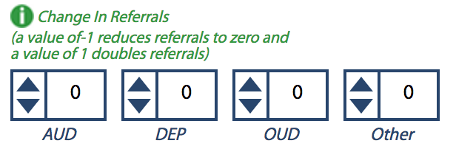

* + 1. We can’t seem to “tab” to impact by keyboard
  1. Question: do we need to be 508 Compliant for Admin/Facilitator screens?

## Vensim Model(s)

1. Replace text: For Iteration B, we will have CC, MM, and Psy vensim files (and associated information provided in this design document). As we had in Iteration A, the model is selected from the Select page.
2. The Vensim models and diagram to use for Iteration B: [or JMR to provide eps file.]
   1. CC
      1. Vensim model has not changed from Iteration B.
      2. Drawing in .eps file format has not changed from Iteration B.
   2. MM
      1. Vensim model has not changed from Iteration B. In Updates to Iteration B below, we describe the addition of two additional output variables, but the variables are already in the previous Vensim model.
      2. Drawing in .eps file format has not changed from Iteration B.
   3. Psy
      1. Vensim model has been updated. Please use:  
         Psy_PROD_Iteration_C.vmf (this is based on PSY_v9_2017_12_21.mdl)
   4. Agg
      1. Vensim model is new. Please use:  
         Agg_PROD_Iteration_C.vmf (this is based on agg_v05_2017_12_26_2.mdl)
3. Model Parameters temple -- Please use ModelParameters_Template_Iteration_C.xlsx as the template (esp for developing and testing Psy and Agg models).
4. Use of Arrays
   1. The MM model and Agg model uses arrayed variables where some of the Vensim variables are arrays with index values. The “decode” of the arrayed variables are indicated below.
      1. MM: dep, aud, oud, other
      2. Agg: Intake, Psych, EBPsych, CC, MM, Adjunctive, Group

## Roles

This has not changed from Iteration B, but includes as a reference.

1. We will have three roles for the simulation
   1. Administrator (or Admin, or Facilitator; these terms are used interchangeably throughout this document)
   2. Team Lead
   3. Player

Table 01

|  |  |  |
| --- | --- | --- |
| Role | Examples | Description |
| Administrator (or Admin, or Facilitator; these terms are used interchangeably throughout this document) | 1. Lindsey Zimmerman 2. Jane Branscomb 3. Stacey Park 4. James Rollins 5. Howard Park | 1. These are instructors and other “core project” team members. 2. Administrators will also be able to access Admin-only screens/features. |
| Team Lead | NA at this time. | 1. At a given time, there is only on Team Lead for a team. 2. Only the Team Lead can select a Vensim Model and XL file for the team. |
| Player | NA at this time. | 1. This is the rest of the team members (aside from the Team Lead). |

# Page Flows, Wireframes, and Graphics

## Graphics

1. The VA Team PSD logo has been changed as indicated in the graphic below.
2. The plus sign “+” has been removed from the feedback loop symbol, and the VA has been enlarged to the same width as the “Team PSD” portion of the logo.

Figure 02



## Wireframes

1. We have the following changes and clarifications to the previous Wireframes described in the Iteration A and Iteration B Design Documents.
   1. For the Team Lead and Player roles (i.e., NOT Admin/Facilitators), the changes to the wireframe and page arrangement are:
      1. Page renames
         1. Rename the “Select” Page to “Home” Page.
         2. Rename the “Train” Page to “Help” Page.
      2. Re-order of top navigation links
         1. Instead of: SELECT | PLAY | TRAIN | CHAT | LOGOFF
         2. Change to: HOME | PLAY | CHAT | HELP | LOGOFF
      3. “Home” Page (this is what used to be “Select” Page)
         1. Have the following text directly on the “Home” Page at the top (not inside any Tiles:  
              
            “Welcome to the VA Team PSD simulation! This is a tool for clinic teams to explore, learn, and make decisions together for optimizing services to Veterans with their existing or projected resources.  
              
            Remember the key is Modeling to Learn – team learning to improve team decision-making. As you and your team play and discuss experiments, you’ll gain deeper clarity about how your clinic works, what’s within your control to change, and how to make decisions that balance a lot of objectives at once.”
         2. Rename the “Main” Tile to “Select” Tile.
         3. Move the “Play Simulation” button just after the “Select” Tile.
         4. Remove the “Welcome” Tile and the associated content. Note: we may re-add the “Welcome” Tile and add some content for Iteration D.
         5. For Team Leads, add a new Tile “Upload Model Parameters” below the “Play Simulation” button. Please see description below.
      4. For the “Help” Page content, pls see Help Page Content.
   2. For the Admin/Facilitators, the changes and clarifications to the wireframe and page arrangement are:
      1. Clarifying Pages and Tiles for Admin/Facilitator
         1. “Home” Page (this is what used to be “Select” Page) is only used to upload Model Parameters.
            1. Add a new Tile “Upload Model Parameters”. Please see description below.
            2. The Admin/Facilitator will NOT have a “Play Simulation” button.
         2. “Play” Page is renamed as “Dashboards” Page and is now only showing Outputs Tile, which is described below. Therefore, while “Play” Page is still needed, it is simpler than the Team Lead and Player views.
         3. “Administer” Page (which had been considered in previous Iterations) is no longer needed.
      2. Re-order of top navigation links
         1. Instead of: SELECT | PLAY | TRAIN | CHAT | LOGOFF
         2. Change to: HOME | DASHBOARDS | CHAT | HELP | LOGOFF
      3. Admin/Facilitator’s Chat Page
         1. Since Facilitators log into the “Group” (which will contain all Teams) and not at the “World” (or Team) level, the Chat Tiles will be slightly different for Admin/Facilitator.
         2. There is no “Team Chat” Tile for Admin/Facilitator.
         3. We still have “Team Lead” Tile for Admin/Facilitator.
      4. For the “Help” Page content, pls see Help Page Content.

# SOW Requirements

This section describes the requirements as outlined in the SOW.

We list the requirements organized by WW’s SOW, then cross-listed to VA’s SOW (Statement of Work). More detail of the mapping of tasks can be found on "VA_PSD_Iterations_Features_HCP7.xlsx”.

As in previous Iteration Design Documents, the headings are in the format “WW Task / VA SOW”.

## 2.02 Admin’s Dashboard / Administration Features / 5.2.1. Basic Administrative Functionality for administration from the National Center for PTSD

1. Many of the Administrative Functionality of provided by the Forio platform. For example: the ability to create teams and assign members, impersonate team players, etc.
2. For a description of how we will do user management and setting team names, pls see 2.05 User Management / 5.9.3 Set team name.

## 2.02 Admin’s Dashboard / Administration Features / 5.6.2. Overview page with list of users and their current progress

1. [Have we decided that we do not need this as a separate Tile? Can we incorporate into Facilitator Dashboard?]

## 2.03 Player’s Dashboard / 5.9.10 Decisions Page (for Agg)

1. Below is a diagram that contains labels to describe the following features:
   1. These are standard rate dials - no change format
   2. These are standard stocks - no change in format
   3. There are three builds for this UI:  
      - “Appointments” which includes the True Missed Appts. Rate, Appts. To Reschedule, Rescheduling Rate, Booking Appt. Rate, Appts. Scheduled and Completed Appts. Rate IS THE DEFAULT VIEW and will always show.  
      - All Loops in the “Appointments flow” will build when the “Appts. Loops checkbox is checked by user.  
      - “Patients” which includes Referrals to Team Rate, Patients Waiting to Start Service, Starting Service Rate, Developing a Treatment Plan Rate, Patients in Service, Deciding to Start a New Service Rate, Patients waiting to Start a New Service, Starting a New Service Rate and Ending Service Rate flow will build when the “Patients” checkbox is checked by user.  
      - All Loops in the “Patients” flow will build with the “Patients Loops” checkbox is checked by user.
   4. Patient Group radio buttons are used to show the results of the patient group variables in the stocks and flow readings on the UI. When the “All” radio button is selected, the results are added to give total result.
   5. These Decision Variable icons represent a variable array of 5 variables that correspond to the Decision Tile subheading “Patients Starting a New Service by Patient Group” (See “F” below)
   6. Each of these Patient Group subheadings are represented by 5 variables in an array.
2. Agg (Aggregate) Model Diagram

Figure 03

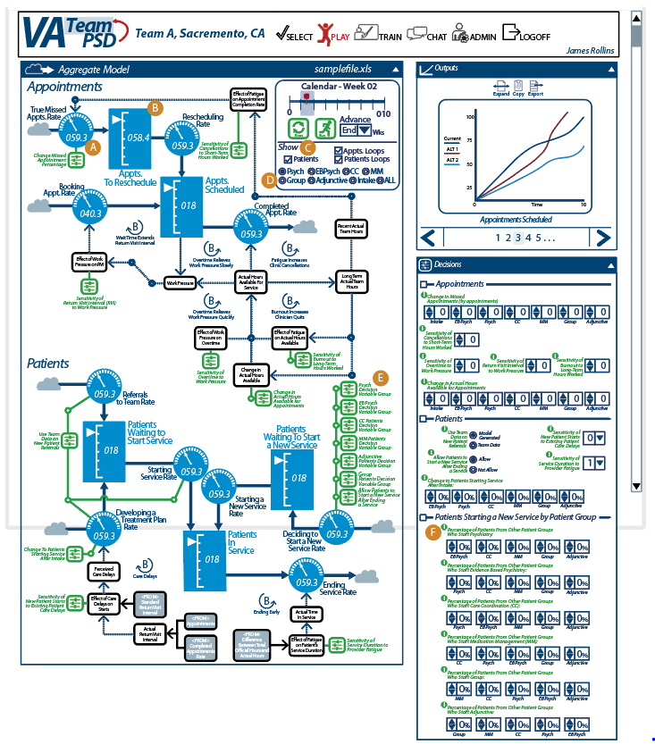

1. Variable Tables -- Link to Google Spreadsheet: [G-SS](https://docs.google.com/spreadsheets/d/1KoyHmZiai6FRC6tmquLPA3541N2N5Lgi_FEdN1HvmFQ/edit#gid=0)

## 2.03 Player’s Dashboard / 5.9.6 Dashboard with access to key metrics (Agg)

1. The functionality has not changed from Iteration B for the AGG model.
2. See text changes as outlined below (these text changes apply to all model views):
   1. “Our Hypothesis” new wording, “Outline the systems story your team believes will cause the outcomes your team expects to observe.”
   2. “Our Results” is changed to “Our Findings” with new wording, “Describe your team’s findings, insights and conclusions from this experiment.”
   3. “Our Decisions” wording is corrected, “Based on what you learned in this experiment, what changes are you ready to make in your practice?”
   4. “Select Control Panel View” is changed to “Change Control Panel View”  
      - “Model Run Alternatives Comparison” changed to, “Compare Model Runs”  
      - “Inter-Model Run Variables Comparison” changed to, “Analyze Variable Arrays”
   5. On the Psy model, “Sankey” selection graphic. Clicking this graphic will open a pop-up window with Sankey Diagrams. This will only work in Psychotherapy Model runs, the Sankey Icon shall remain grayed out (as shown) in other model type outputs screen. See Updates to Iteration B / Sankey Chart basic information for details on Sankey diagrams, pop-up windows and related variables.

Figure 04 - Revised Expanded Outputs Tile

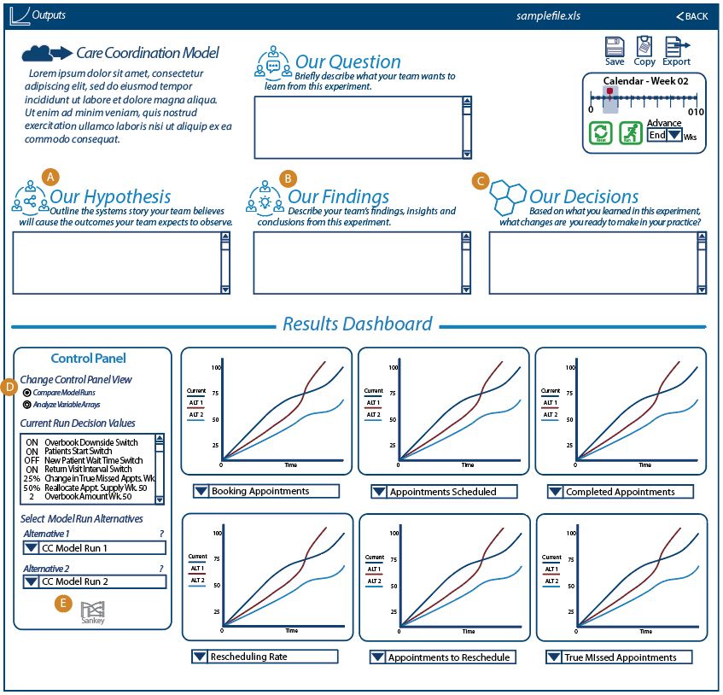

## 2.03 Player’s Dashboard / 5.9.12 Ability to export data as a Comma Separated Values (CSV) File

1. The functionality has not changed from Iteration B.
2. Depending on latency, we may decide to record only at each Week instead of sub-week (for example, only record every 8th or 16th data point).
3. Although we are not making use of the data yet, we want to log the event (i.e., when User clicks on “Copy” or “Export” in the Outputs Tile or in the Expanded Outputs Tile) for use in “Use/Evaluation Analytics”.
   1. For more information, please see [link](https://docs.google.com/document/d/1Cj6zUd1i23b3wzzAFBZDabHEUh2FgxzaFbM_K0YtBWs/edit#heading=h.1edtvtsc2rrv) in Iteration B.
   2. Recording each time a User (i.e., a Player or Team Lead Role) clicks on “Copy” or “Export” may require a separate data store (from the existing Forio capability of recording “run data”). For example, in one run, a Player may click on “Copy” and “Export”, or a Player may only click on “Export”, or a Player may choose to do neither “Copy” nor “Export”.

## 2.03 Player’s Dashboard / 5.10.01 Introduction & Help: Text-based 'prepare' section

1. This feature/requirement is not needed.
2. Per BaseCamp discussions (Testing the VA PSD Simulation, <https://basecamp.com/2223176/projects/11877143/messages/73662154>, comments posted on 21-Dec) we will no longer need “prepare” text.  
   NOTE: WaferWire cannot access the BaseCamp link above; it is includes as a reference for Takouba.
3. We had planned on having the “prepare” text as part of the “Welcome” Tile in the “Select” Page.
4. If we decide we need to re-include the “Welcome” Tile and any “prepare” text, we can add that for Iteration D.

## (Help Page Content) 2.03 Player’s Dashboard / 5.10.02 Introduction & Help: Text-based 'help' section AND 2.03 Player’s Dashboard / 5.10.03 Integrate tutorial videos AND 2.03 Player’s Dashboard / 5.10.04 Interactive tutorial walking through the user interface

1. This section describes the text and other content (including arrangement) for the “HELP” Page (for all Users).
2. The “Help” Page will have the following four Tiles
   1. Using this tool
   2. Understanding the models
   3. Terms and abbreviations
   4. References and links
3. The content for the four Tiles (including subheadings and placeholders for Iteration C):
   1. Using this Tool
      1. **Navigation**  
           
         As shown on the main navigation bar, there are four main sections to this tool:  
           
         **Home** – This is the initial welcome page. It’s also the place where play actually starts for a given session. You can choose to either join an existing game or start a new one by choosing which model and set of team data you want to use for the session. Click “Play Simulation!” when you’re ready.  
           
         **Play** – Here you see a diagram of the model you chose: Care Coordination, Medication Management, Psychotherapy, or Aggregate. The header above it also shows which dataset is in use. You may need to scroll down to see all of the diagram. (See Help: The Models for explanations of these diagrams and each of the models.)   
           
         There are two other tiles on this page: Decisions, where you choose what decisions you want to simulate – which factors you’d like to simulate; and Results, where graphs of the results of your simulation will appear after you hit “Run”.  
           
         **Help** – You are here!  
           
         **Chat** – Chat lets you converse with either the rest of your team or with the Modeling to Learn facilitator. Note that comments are saved permanently. Also, like most chat applications, you can’t separate conversations by threads. So it’s best to only send chat messages for the facilitator while you are in a live session with them. If you’re experimenting on your own at another time, you might want to post a message to your teammates that they can see and respond to when they log in next.  
           
         TBD: Audio/Video – Audio of the above for 508, or is that accomplished by an app? Narrated version with screen shots for 508 and/or just different learner preferences?[1]
      2. Creating a simulation  
           
         Include the same youtube video link from previous Iteration development, along with the text preceding (before, or above) the video.  
           
         “The following video is for demonstrating the ability to embed a video.”
      3. Viewing results
      4. Saving and exporting
   2. Understanding the models
      1. Diagram basics and terminology
      2. Care Coordination
         1. Text (video script)
         2. Video (captioned)  
            Embed the following video: [link or instructions to be provided]
         3. Variables and parameters (table with units, definitions, and sources)
      3. Medication Management
         1. Text (video script)
         2. Video (captioned)  
            Embed the following videos (we will prob have two videos): [link or instructions to be provided]
         3. Variables and parameters (table with units, definitions, and sources)
      4. Psychotherapy
         1. Text (video script)
         2. Video (captioned)
         3. Variables and parameters (table with units, definitions, and sources)
      5. Aggregate
         1. Text (video script)
         2. Video (captioned)
         3. Variables and parameters (table with units, definitions, and sources)
   3. Terms and abbreviations
   4. References and links

## 2.04 Retune the Model for Different Locations / 5.3.1 Framework for Multiple Cities, States, other Locations AND 5.3.2 Ability to Upload Datasets by Location

1. There are a few ways we are accommodating the ability to handle multiple locations.
   1. Some of the is was described in Iteration B design and is included here for reference:
      1. How we are setting up teams to be a “team at a location”, for example “Team ATS, Menlo Park” is a team. For more information on this, see 2.05 User Management / 5.9.3 Set team name.
      2. How we are enabling the use of external Excel files to bring in data for the Vensim model.
      3. To manage the team names and Excel files, we recommend a easy-to-use naming convention.
   2. We describe below how a Facilitator or a Team Lead can upload external data files.
2. “Upload Model Parameters” Tile.
   1. Please see Wireframes for context and more information on how the pages are arranged.
   2. Text for “Upload Model Parameters”

“Use the following to upload Model Parameters files to be used by the Simulation. Please note:

1. The files must be based on the Model Parameters Excel template available here. [link will be provided later.]
2. The template will have four distinct sheets for each model (Care Coordination, Medical Management, Psychotherapy, and Aggregate), and the names of the sheets must not be changed.
3. Each XL file must have a unique name from previous XL files. We recommend using a file naming scheme that makes it easy to track the files (for example, using team names and dates).
4. Avoid special characters in the filename: ( ) { } [ ] = + . , ; : ’ ” \ / | * & ^ % $ # @ !.

Note: no validation is performed during upload of Excel files to check for format or correctness of data.

* 1. UI examples for “Upload Model Parameters” Tile:

Figure 05

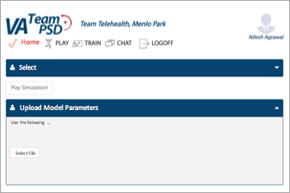  
  
Figure 06

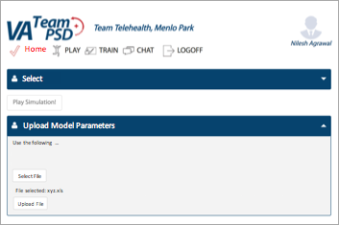

* 1. UI elements and workflow
     1. If an XL file has not been selected, Figure 05 is shown.
     2. “Select File” opens up a “select file” chooser that allows the User to browse through a local directory and select a file with “.xls” or “.xlsx” format. The chooser should allow a “cancel” in case User does not want to select a file.
     3. After the User selects a file, the filename and “Upload File” button is shown (please see Figure 06).
     4. Clicking on “Upload File” does the following: Checks the filename to make sure that no previous filename exists.
        1. If it exists, a message comes back: “Filename already exists. Please select a different file, or rename the file to a different filename.” Then the User is taken back to Figure 06.
        2. If it does not exist:
           1. Uploads the file into the appropriate Forio directory for access by Simulation for models.
           2. Updates the list of available XL filenames for availability in drop-down in the “Select” Tile.
           3. Show a message to User “File [insert filename] successfully added.”
           4. User is taken back to Figure 05.

## 2.05 User Management / 5.4.2 Upload List of Users from a Comma Separated Values (CSV) file

This is a feature already supported by Forio Epicenter and was addressed in Iteration B.

## 2.05 User Management / 5.9.3 Set team name

1. All Users will be in one Group. Name of Group: “VA_PSD_Group”.
2. Each Team will be one distinct World. Takouba will provide a list of Worlds and how each World (by World number) will be mapped to a Team. When we display a Team Name, the Simulation will look up the Team Name based on the User’s World.
3. Each User will be assigned to one World that corresponds to their team.
   1. To be determined: If a User is part of more than one Team, how do we handle if we cannot assign more than one email address to a User?

## 2.06 Game Assignment / 5.4.3 Assign Users to Roles (Role Player, Simulation User role) and Teams

These requirements are a combination of features already supported by Forio Epicenter and how we addressed the requirements Iteration B.

## 2.06 Game Assignment / 5.4.4 Remove Users/ Reset Passwords/ Other User-management Features

These requirements are a combination of features already supported by Forio Epicenter and how we addressed the requirements Iteration B.

## 2.07 Game Progress / 5.9.8 Scoring / Compare to Other Teams (only for Admins)

1. The Facilitator Dashboard (see Figure 7 below) shall consist of gauges that use similar visual movements as the rate gauges in the UI. These will be larger and have colors that range from VA Red on the far left, to VA yellow in the middle and VA Green on the right. The values for the gauges will be determined by the Scoring Criteria described below. The settings for current rows (i.e., which teams have been selected, and for each team, which games have been selected) shall be saved in browser cookies, so if the Facilitator logs out and returns, they will see their current listing of open expanded and collapsed rows. The Facilitator can choose to collapse a row to save space, but there will be no “save” routine for the dashboard.
2. Scoring Criteria
   1. Run model: If the users start a game, and load a data set, they will earn +20 points. The dial will move as illustrated in A.
   2. Text in "Our Question": If the users fill in any text in the “Our Question” text-field, they will earn an additional +20 points. The dial will move as illustrated in B.
   3. Text in "Our Hypothesis": If the users fill in any text in the “Our Hypothesis” text-field, they will earn an additional +20 points. The dial will move as illustrated in C.
   4. Text in "Our Findings": If the users fill in any text in the “Our Findings” text-field, they will earn an additional +20 points. The dial will move as illustrated in D.
   5. Text in "Our Decisions": If the users fill in any text in the “Our Decisions” text-field, they will earn an additional +20 points. The dial will move as illustrated in E.
3. Collapse and Expand icon will collapse or expand each team instance of the dashboard. For example, if the icon in “F1” was clicked, it would result in a collapsed row as shown in “F2”.
4. Choosing a team. The Facilitator would select the drop-down menu shown in item “G.” The drop-down menu would contain teams the Facilitator can see within their world. A team must be chosen before model files can be listed and presented in the model run drop-down menus as shown in item “K.”
5. Team Roster. The Facilitator can click on the icon next to item “H” to start a pop-up window that has a listing of the team lead and team members on the team.
   1. The pop-up show show a list of the team members for the selected Team. The Team Lead should be identified with a “-- Team Lead” after the name (or in a separate column).
   2. We want to enable the Facilitator to jump to the “Chat” Page with the selected team auto-selected and shown in the Facilitators Tile. In other words, if the Facilitator clicks on chat icon next to the Team Leads name (in the Team Roster pop-up”, the Facilitator will be taken to the “Chat” Page, and the chat window will show the chat session with the selected Team Lead.
   3. If the Team has not been selected, disable the Team Roster icon.
6. Team Statistics. The facilitator can click on the icon next to item “I” to view a pop-up that contains team statistics. An empty pop-up window will suffice for Iteration C. We will determine appropriate statistics in Iteration D.
   1. If the Team has not been selected, disable the Team Statistics icon.
7. Close. When the facilitator clicks on the “Close” icon indicated in item “J” the row will close. A warning banner will be displayed asking the user if they are sure they wish to close the row, and that the row will not be saved. If the user selects “Yes,” the row will close and there will be no record of this dashboard. If the Facilitator wishes to see the row again, then they will need to re-setup the row.
8. Add Team. By clicking on this icon, shown by item “L” a new expanded row will show. The Facilitator can start as many rows as desired.

Figure 07 - Facilitator Dashboard

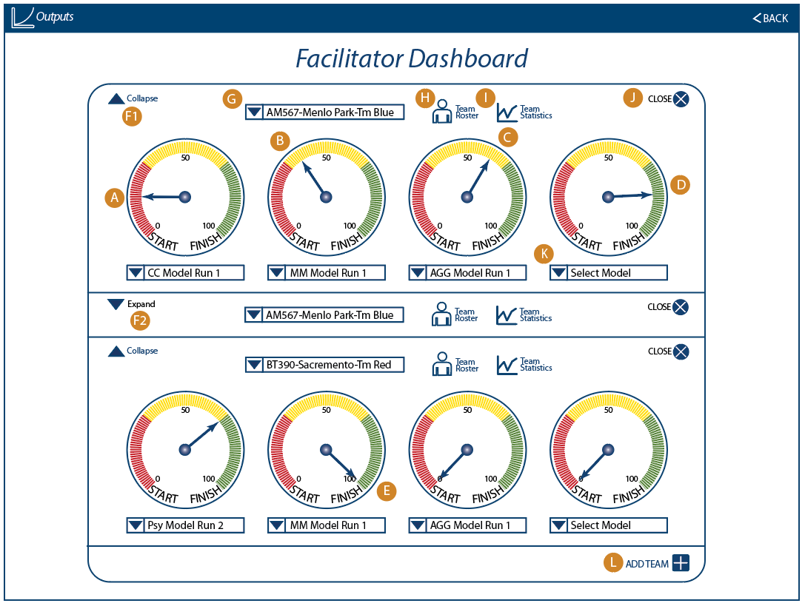

## 2.10 Exogenous Events / 5.8.1 Allow Administrator to Trigger Exogenous Events in the Simulation

1. This requirement is no longer needed, based on call on 17-Nov 2017 “Lindsey + James Review UI Decisions and Schedule Notes”.
2. More specific info is available: <https://basecamp.com/2223176/projects/11877143/messages/73934405>  
   NOTE: WaferWire cannot access the BaseCamp link above; it is includes as a reference for Takouba.

## Unspecified in WW workplan / 5.7.2 Ability of Manager/Facilitator to Impersonate Team Members to View Decision Details

1. This is a feature already supported by Forio Epicenter.
2. WW needs to resolve a redirect issue, described in Naren’s email (04-Dec): “Impersonation sets a cookie indicating you're logged in and forwards you to the index.html page; it looks like in your case index.html is the login page. Typically index.html is the main game and login.html is the login, but if you want to maintain your current naming conventions, you can just add a check to the login page to automatically send users to main.html if they're already logged in…”

## Updates to Iteration B

1. Please see above Wireframes for a description of some modifications to the Wireframe for Iteration C.
2. We have added a few more variables to the MM model for Expanded Output Tile
   1. These are for “SAIL Metrics”
   2. The variables to add are indicated below

Table 02

|  |  |  |  |  |  |  |  |
| --- | --- | --- | --- | --- | --- | --- | --- |
| **Vensim Variable** | **Label** | **Group** | **Unit** | **Min** | **Max** | **Default** | **Format/ Gradation** |
| Actual RVI (OUD)  Where OUD is the 3rd index | Actual RVI (OUD) |  |  | 0.0 | 20.0 | NA | NA |
| Actual RVI (DEP)  Where DEP is the 1st index | Actual RVI (DEP) |  |  | 0.0 | 20.0 | NA | NA |

1. We have content for some of the “Ipsum Lorem” text across many tiles. The text and instructions are included in above sections, including Wireframes and Help Page Content.
2. Update to Psy Model, Expanded Output Tile, for Sankey Charts  
   1. This section describes the Sankey Charts that will be available for the Psy Model.
      1. Only the Psy Model will have this feature.
      2. TBD: The Admin/Facilitator may also have access to the Sankey Charts, but access to the Sankey Charts and how the Admin/Facilitator will select the Team will be different from the User or Team Leads.
   2. UI
      1. On the Expanded Outputs Tile, there is a “Sankey” icon at the bottom of the Control Panel area (see Figure 04).
      2. Clicking on the Sankey Icon opens an additional pop-up Tile. See Figure 08.

Figure 08

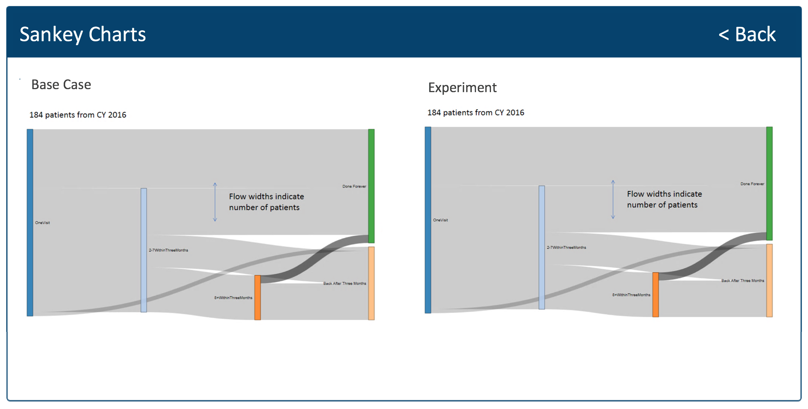

* + 1. Description of the Sankey Charts pop-up Tile (please refer to Figure 08.)
       1. “184 patients from CY 2016” → replace with “PatientNumber Patients”, where “PatientNumber” = SFA + SFB + SFC. The Base Case graph will use SFA + SFB + SFC for Base Case, and Experiment Graph will use SFA + SFB + SFC for Experiment. See Table 03 below.
       2. “Flow widths indicate number of patients” and associated double-headed arrow are NOT drawn.
       3. The vertical bars (blue, light blue, etc.) are shown along with the revised labels:

Table 03

|  |  |  |
| --- | --- | --- |
| Color | Label in Figure 08 | Label to Use in Simulation |
| Blue | OneVisit | One Visit |
| Light Blue | 2-7WithinThreeMonths | [Need to confirm with client] |
| Orange | 8+WithinThreeMonths | [Need to confirm with client] |
| Green | Done Forever | Completer |
| Tan | Back After Three Months | [Need to confirm with client] |

* 1. Sankey Chart basic information
     1. References
        1. http://bl.ocks.org/d3noob/c9b90689c1438f57d649
        2. <https://developers.google.com/chart/interactive/docs/gallery/sankey>
     2. Our Sankey Charts will always have ONLY eight Sankey Flows (A through H) as indicated in the Figure below.

Figure 09

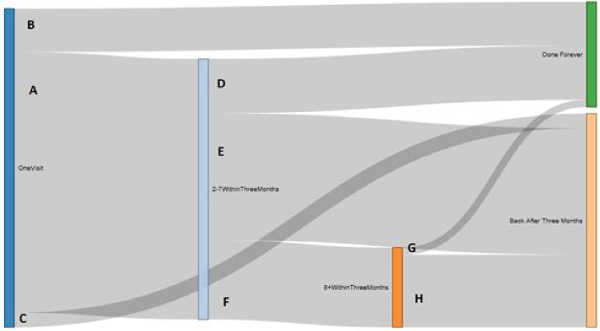

* + - 1. For reference we will call each flow “SFA” for Sankey Flow A, “SFB, etc. We will have SFA to SFH.
      2. In order to produce the Sankey Charts, we need values for all the flows (SFA through SFH).
      3. We want to render TWO versions of the Sankey Charts
         1. One is “Base Case”, the second is “Experiment”.
         2. Each chart will have 7 values that are gathered from Vensim variables.
         3. Formulas using Vensim variables are below:

Table 04

|  |  |  |
| --- | --- | --- |
| Flow | Base Case Calculation | Experiment Calculation |
| A | ("% Go on to 2-7 Data in <3mo")*"SankeyScalar" | "E2" * "(Cohort Ratio)" |
| B | ("%Visit1-n-Done Data")*"SankeyScalar" | "E3" * "(Cohort Ratio)" |
| C | (1-("% Go on to 2-7 Data in <3mo" + "%Visit1-n-Done Data"))*"SankeyScalar" | "E4" * "(Cohort Ratio)" |
| D | ("%Visit2-7-n-Done Data")*(("% Go on to 2-7 Data in <3mo")*"SankeyScalar") | "E5" * "(Cohort Ratio)" |
| E | (1-("%Visit2-7-n-Done Data" + "%Visit2-7-n-More<3mo Data"))*(("% Go on to 2-7 Data in <3mo")*"SankeyScalar") | "E6" * "(Cohort Ratio)" |
| F | ("%Visit2-7-n-More<3mo Data")*(("% Go on to 2-7 Data in <3mo")*"SankeyScalar") | "E7" * "(Cohort Ratio)" |
| G | ("%Visit8PL-n-Done Data")*(("%Visit2-7-n-More<3mo Data")*(("% Go on to 2-7 Data in <3mo")*"SankeyScalar")) | "E8" * "(Cohort Ratio)" |
| H | (1-("%Visit8PL-n-Done Data"))*(("%Visit2-7-n-More<3mo Data")*(("% Go on to 2-7 Data in <3mo")*"SankeyScalar")) | "E9" * "(Cohort Ratio)" |

1. Text changes to Expanded Output Tile. Please see description and text changes in 2.03 Player’s Dashboard / 5.9.6 Dashboard with access to key metrics (Agg).

# Iteration C Design-Related Questions

We can use this section to ask and address questions.

1. Questions for Forio
2. Questions for client

# Recordings of Calls

1. Tue 19-Dec: [recording](https://fccdl.in/1shgm0xu4)

1. Please include the preceding text in the Simulation, including “TBD: ”.